Project Proposal

Custom Architecture Firm Website

TAD

1. Project Overview
The objective of this project is to design and develop a custom-built, modern, and visually refined website for TAD, an architecture firm. The website will serve as TAD’s primary digital presence, representing its architectural philosophy, leadership, services, and portfolio through a clean, structured, and image-driven interface.
The website will be fully custom-developed (React) to ensure high performance, flexibility, and design precision. Special emphasis will be placed on minimalism, typography, spatial balance, and high-quality visuals—core elements that reflect architectural excellence.

2. Project Objectives
- Develop a fully responsive, custom-coded website for TAD
- Establish a strong, professional, and premium online presence
- Showcase architectural and design projects through structured portfolio layouts
- Present services clearly with dedicated detail pages
- Ensure fast loading speed and optimized performance
- Maintain compatibility across all major browsers and devices
- Create a scalable foundation for future growth
- Implement SEO-ready structure and analytics integration

3. Scope of Work

Website Design & Development Services

Phase 1 – Discovery & Planning (Week 1)
- Discovery session to understand TAD’s brand vision, architectural style, and target audience
- Define website sitemap and information architecture
- Finalize content structure and technical requirements
- Align expectations, milestones, and deliverables
Note:
The client will provide all final content including written copy, project details, images, CEO profile, and contact information before development begins. Placeholder content may be used temporarily for layout purposes.

Phase 2 – UI/UX Design (Week 2)
- Creation of wireframes for all major pages
- Development of visual design aligned with architectural aesthetics
- Finalization of color palette, typography, spacing, and layout grids
- Design review and revision based on client feedback
- Final design approval before development

Phase 3 – Development & Content Integration (Week 3)
- Custom front-end and back-end development
- Pixel-perfect implementation of approved designs
- Responsive optimization for desktop, tablet, and mobile
- Integration of client-provided content across all pages
- Implementation of smooth navigation and transitions
- Performance optimization and clean coding practices

Phase 4 – Testing, Review & Launch (Week 4)
- Cross-browser and cross-device testing
- Performance and speed optimization
- Bug fixing and UI refinements
- Client review and final revisions
- Google Analytics and SEO essentials setup
- Live deployment and final quality checks

4. Deliverables
- Fully custom-developed architecture website
- Responsive design across all devices
- Modern, minimal, and image-driven UI
- Structured portfolio and service layouts
- SEO-ready website structure
- Performance-optimized codebase
- Analytics integration
- Live deployment and handover

5. Website Structure & Pages

Parent Pages
- Home
- Portfolio
- Services
- Meet the CEO
- Contact Us

6. Website Sitemap

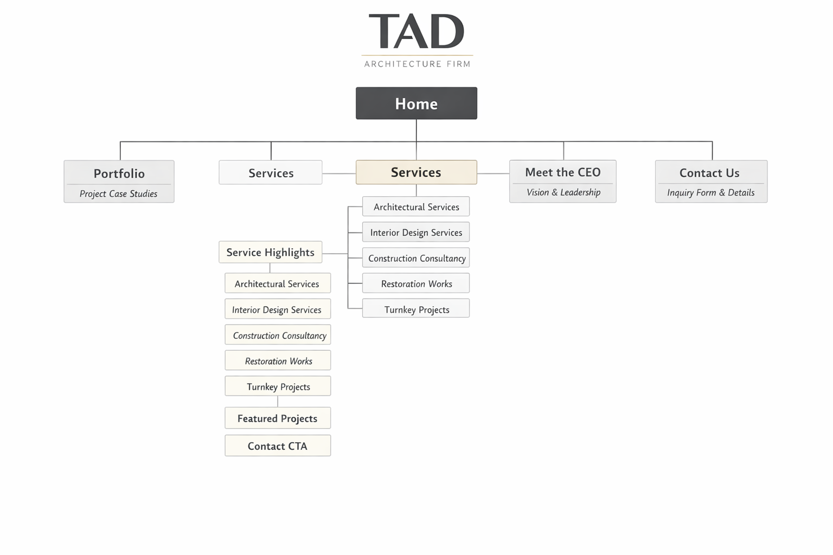

Service Subpages
(Accessible under Services and highlighted on the Home page)
- Architectural Services
- Interior Design Services
- Construction Consultancy
- Restoration Works
- Turnkey Projects

7. Project Timeline
Phase | Description | Duration
Week 1 | Discovery, planning, sitemap, and content preparation | 5 days
Week 2 | UI/UX design, wireframes, and visual approval | 5–6 days
Week 3 | Custom development and content integration | 6–7 days
Week 4 | Testing, revisions, optimization, and deployment | 5 days
Total Duration | Project Completion | 4 Weeks

8. Post-Development Support (Optional – Paid Monthly)
Monthly Maintenance Fee: Rs. 5,000/-
Includes performance monitoring, bug fixes, minor content updates, backups, and technical support.

9. Future Enhancements & Upgrades
- Blog or insights section
- Advanced SEO and performance enhancements
- Interactive project filters and animations
- Multilingual support
- CMS integration
- Periodic design refreshes

10. Project Cost & Payment Milestones

Total Project Cost: Rs. 40,000/-

Payment Structure
- 50% Advance Payment: Rs. 20,000/-
(Due upon project confirmation and before commencement)
- On completion of project – 50%: Rs. 20,000/-
(Upon final website delivery and before live deployment)

Hosting Charges
- Hosting Provider: Hostinger
- Annual Hosting Fee: Rs. 8,000/- per year
(Billed separately and payable annually)

11. Access & Ownership

Upon completion of the website and final payment, all login credentials and access details related to the project will be fully handed over to the client. This includes, but is not limited to:

Hosting account credentials

Vercel deployment account access

GitHub repository access

The client will have full ownership, administrative control, and unrestricted access to the website, source code, hosting, and deployment infrastructure after project completion.

12. Acceptance
By signing below, the client confirms acceptance of the scope, deliverables, timeline, and payment terms outlined in this proposal.
Client Name: _________________________
Signature: ___________________________
Date: _______________________________

